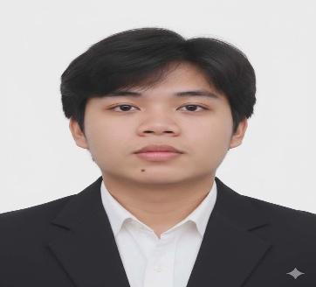
LEMAR C. PARAS
Guinsay Danao City, Cebu
09163887817/ paraslemar@gmail.com
Career Objective:
To gain any position that will allow me to put my educational knowledge in Information Systems and ability to work well with others to good use in a competitive industry, allowing me to further my personal growth goals.

Education:
Senior High School: Talamban National High School
Borbajo St., Talamban, Cebu City
2021-2023
College: Colegio de San Antonio de Padua
Bachelor of Science in Information System
Guinsay, Danao City, Cebu
2023-Present
Language :
English,Tagalog,Cebuano(Dialect)
Personal Data:
Age: 20
Date of Birth: December 23, 2005
Place of Birth: Villaba, Leyte
Status: Single
Nationality: Filipino
Religion: Catholic

Technical Skills:

Programming Languages
- PHP
- Java
- JavaScript
- Python
Web Development & Database Technologies
- Laravel Framework
- HTML5
- CSS3
- MySQL
- XAMPP
- Supabase

Core Competencies:
- Database Design & Normalization
- CRUD Operations
- Role-Based Access Control (RBAC)
- Basic AI Integration Concepts
- System Analysis and Design
- Microsoft Office (Word, Excel, PowerPoint)

CERTIFICATIONS & ACHIEVEMENTS
- NC II – Web Development – TESDA (2025)
- Dean’s Lister – First Year College
- President’s Lister – Second Year to Present (4th Year)
- Consistent Academic Excellence Awardee

ACADEMIC PROJECT
Automated Research Management System with AI Support (Capstone Project)

Role: Project Leader & Programmer
- Leading the project team in planning, designing, and implementing the system workflow.
- Applying system analysis principles to improve efficiency and maintain secure data handling.
- Coordinating team members, assigning tasks, and ensuring deadlines are met.

LEADERSHIP EXPERIENCE
President – Innovators Club of CSAP (2025-2026)
- Leading innovation-driven academic and technical initiatives.
Public Information Officer – Student Body Organization (SBO) (2025-2026)
- Creating and managing official announcements and communications.
Class Mayor (2023 – Present)
- Representing the class in academic and administrative matters.
Publisher (Creative) - Supreme Student Council of CSAP (2026-2027)
- Helping the council publish school projects.

Character Reference
Mr. Alvin Joseph Valdez, MIT
IT Instructor/Software Engineer
09929501109

Emily Geotina
Software Automation Test Engineer
Accenture, Inc.
09454334704

Michael James Geotina
Software Engineer
Accenture, Inc.
09954576166

